Chapter 2, Problem 40.

For the ladder network in Fig. 2.104, find I and R_{eq}.
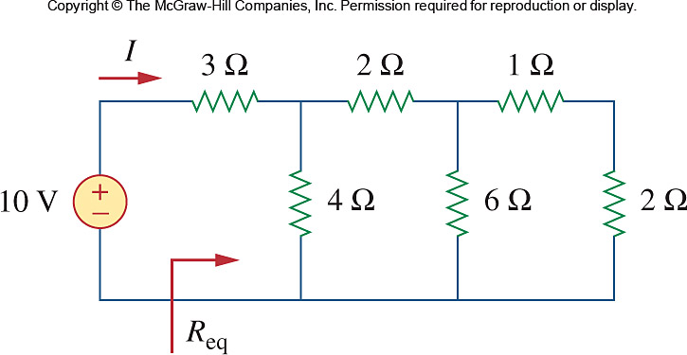
8 Ω
15 V

Figure 2.104
For Prob. 2.40.

